BI

Mini Project   
Flight Price Prediction Analysis

**SUMBITTED BY -**

**SPRINT 4 -**

**Sandhya M**

**Kanchan Vinod Kumawat**

**Priyanshi Shukla**

**Sayali Anil Katolkar**

**Aditi Mahendra Sonawane**

**Bhumika Yadav**

**1. Table of Contents**

1. Introduction
   1. Setup Checklist for Mini Project
   2. Instructions
2. Problem Statement
   1. Objective
   2. Abstract of the project
   3. Technology used:
3. **Execution And Result**
4. **Conclusion**

**INTRODUCTION**

The objective of the study is to Analyse the flight booking dataset obtained from “Ease My Trip” website and to conduct various statistical hypothesis tests to get meaningful information from it.

The 'Linear Regression' statistical algorithm would be used to train the dataset and predict a continuous target variable. 'Easemytrip' is an internet platform for booking flight tickets, and hence a platform that potential passengers use to buy tickets.

A thorough study of the data will aid in the discovery of valuable insights that will be of enormous value to passengers

## SETUP CHECKLIST FOR MINI PROJECT

### Minimum System Requirements

* + - Intel Pentium 90 or higher (P166 recommended)
    - Microsoft Windows 2010 or above.
    - Memory: 4GB of RAM (4GB or more recommended)
    - Internet Explorer 10.0 or higher
    - Snowflake and Cloud(AWS/Azure) access

# 2.PROBLEM STATEMENT

## OBJECTIVE

Development of an Analysis to predict the price of the flight

## ABSTRACT OF THE PROJECT

The project is to develop Analysis to predict the price of the flight.

## TECHNOLOGY USED:

* + - Snowflake
    - Cloud (AWS)

**Project Flow:**

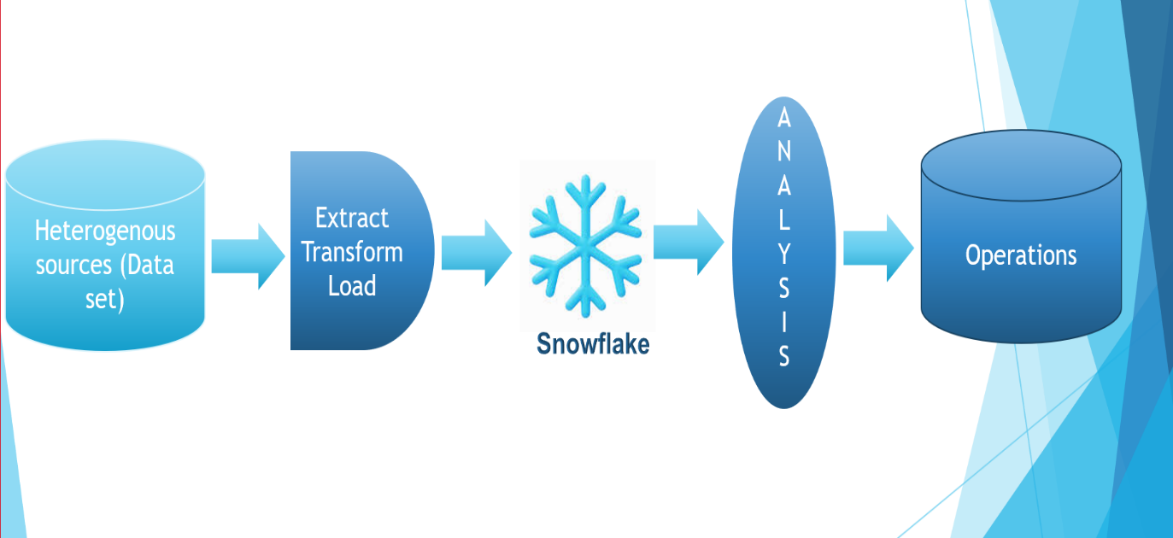

## Execution :

**CODE : PYTHON SCRIPT :**

import pandas as pd

chunk_size = 42879

batch_no = 1

for chunk in pd.read_csv('/content/Clean_Dataset.csv' , chunksize=chunk_size, encoding= 'unicode_escape'):

  chunk.to_csv('Airlines' + str(batch_no) + '.csv' , index=False)

  batch_no+=1

**Result:-**

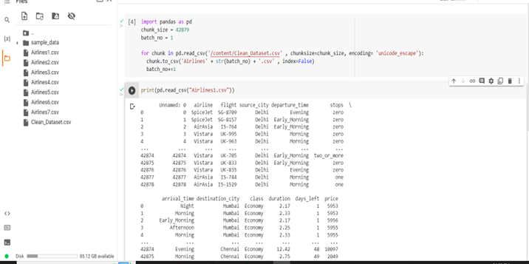

**Fig : Splitting into multiple files using python script**

**SNOWFLAKE :**

**-------CREATING DATABASE---------**

create database sprint4;

**---------AWS INTEGRATION EXTERNAL STAGE----------**

create or replace storage integration s3_int

type = external_stage

storage_provider = s3

enabled = true

storage_aws_role_arn = 'arn:aws:iam::242650538488:role/sprint-4-role'

storage_allowed_locations = ('s3://sprint-4-bucket/');

DESC INTEGRATION s3_int;

**-----CREATE FILE FORMAT------**

create or replace file format my_csv_format

type = csv field_delimiter = ',' skip_header = 1 null_if = ('NULL', 'null') empty_field_as_null = true;

desc file format my_csv_format;

**----STAGE CREATION--------**

create or replace stage my_s3_stage

storage_integration = s3_int

url = 's3://sprint-4-bucket/'

file_format = my_csv_format;

List @my_s3_stage;

select t.$1 as row_id , t.$2 as airline , t.$3 as flight , t.$4 as source_city , t.$5 as departure_time , t.$6 as stops ,

t.$7 as arrival_time , t.$8 as destination_city , t.$9 as class , t.$10 as duration , t.$11 as days_left , t.$12 as price

from @my_s3_stage/ t;

**-----CREATING TABLE------**

create or replace table mytable2

(row_id number , airline string , flight varchar , source_city string ,

departure_time string , stops string , arrival_time string , destination_city string , class string ,

duration varchar , days_left number , price number);

copy into mytable2

from @my_s3_stage

file_format = (type = csv field_optionally_enclosed_by='"',skip_header=1)

pattern = '.*.csv'

on_error = 'skip_file';

select * from mytable2;

**Result:-**

**Fig : Loading data into the table using External Stage in Snowflake**

**------CREATING TASK MYTASK---**

CREATE or replace TASK mytask

WAREHOUSE = my_wh

SCHEDULE = 'Using CRON 0 0 * * THU Asia/Kolkata'

TIMESTAMP_INPUT_FORMAT = 'YYYY-MM-DD HH24'

AS

copy into mytable2

from (select t.$1,t.$2,t.$3,t.$4,t.$5,t.$6,t.$7,t.$8,t.$9,t.$10,t.$11,t.$12 from @my_s3_stage/ t)

file_format = (type = csv field_optionally_enclosed_by='"')

pattern = '.*.csv'

on_error = 'skip_file';

SHOW TASKS

alter task mytask resume;

alter task mytask suspend;

**------CREATING SNOWPIPE--**

create or replace pipe snowpipe auto_ingest=true as

copy into mytable2

from @my_s3_stage

file_format = (type = csv field_optionally_enclosed_by='"')

pattern = '.*.csv'

on_error = 'skip_file';

show pipes;

alter pipe snowpipe refresh;

select * from mytable2;

select SYSTEM$PIPE_STATUS('snowpipe')

select * from table(validate_pipe_load(

pipe_name=>'sprint4.PUBLIC.snowpipe',

start_time=>dateadd(minute, -4, current_timestamp())));

select *

from table(information_schema.copy_history(table_name=>'mytable2', start_time=> dateadd(minute, -4, current_timestamp())));

create or replace stream sprint4 on table mytable2;

select * from sprint4;

**-----CREATING TABLE TARGER_T-----**

create or replace

table target_t(row_id number , airline string , flight varchar , source_city string ,

departure_time string , stops string , arrival_time string , destination_city string , class string ,

duration varchar , days_left number , price number,stream_type string default null, rec_version number default 0, REC_DATE TIMESTAMP_LTZ);

--select * from tgt_merge;

**-----CREATING TASK TGT_MERGE-----**

CREATE or replace TASK tgt_merge

WAREHOUSE = my_wh

SCHEDULE = '1 minute'

WHEN

SYSTEM$STREAM_HAS_DATA('sprint4')

AS

merge into target_t t

using sprint4 s

on t.row_id=s.row_id and (metadata$action='DELETE')

when matched and metadata$isupdate='FALSE' then update set rec_version=9999, stream_type='DELETE'

when matched and metadata$isupdate='TRUE' then update set rec_version=rec_version-1, stream_type='UPDATE'

when not matched then insert (row_id , airline , flight , source_city ,

departure_time , stops , arrival_time , destination_city , class ,

duration , days_left , price,stream_type, rec_version ,REC_DATE)

values(s.row_id , s.airline , s.flight , s.source_city ,

s.departure_time , s.stops , s.arrival_time , s.destination_city , s.class ,

s.duration , s.days_left , s.price,metadata$action,0,CURRENT_TIMESTAMP());

ALTER TASK tgt_merge RESUME;

ALTER TASK mytask RESUME;

alter task tgt_merge suspend;

show tasks

select * from target_t;

select * from mytable2;

insert into mytable2 values (1, 'Indigo','SG-8709','Nagpur','Early_Morning' , 'zero' , 'Night' , 'Mumbai' , 'Economy',

2.17 , 1 ,5953 );

delete from mytable2 where row_id=1;

**Result:-**

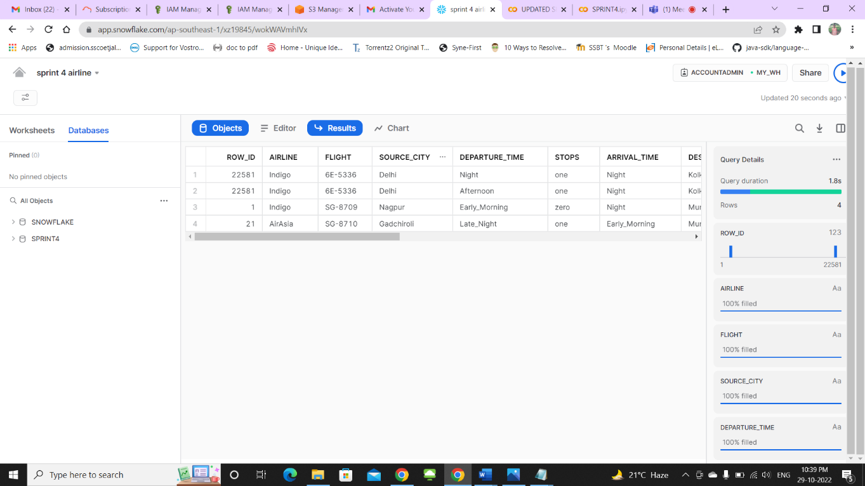

**Fig : Slowly Changing Dimension (SCD 2)**

**----COLUMN LEVEL SECURITY---**

CREATE MASKING POLICY flight_policy AS (VAL STRING) RETURNS STRING ->

CASE

WHEN CURRENT_ROLE() IN ('FLIGHT') THEN VAL

ELSE '******'

END;

create role flight;

CREATE OR REPLACE TABLE flight_number( flight STRING MASKING POLICY flight_policy,flight1 STRING)

INSERT INTO flight_number(flight,flight1)

SELECT flight,flight FROM mytable2;

select current_role();

select current_user();

GRANT SELECT ON flight_number TO ROLE flight;

grant usage on warehouse my_wh to role flight;

grant usage on database sprint4 to role flight;

grant usage on schema public to role flight;

grant role flight to user ADITI0503;

select * from flight_number;

**Result:**

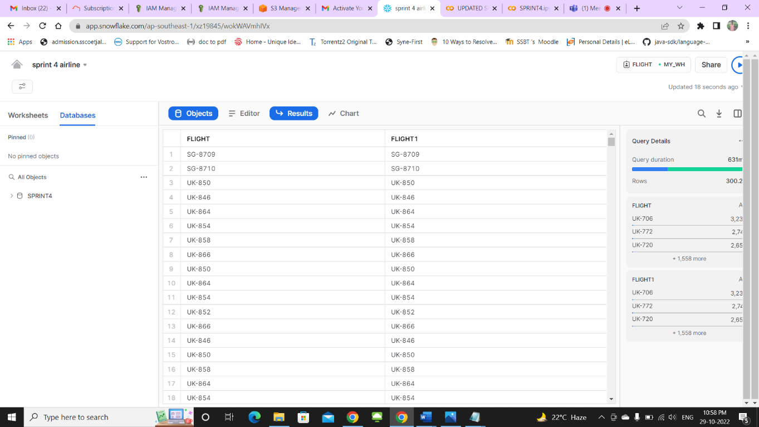

**Fig : Column Level Security**

**-------ROW LEVEL SECURITY----**

**-- Apply Row-level security using Secure Views**

**-- create a secure view**

**------STEP 1 : CREATION OF ROLE----**

create or replace role Spicejet;

create or replace role Vistara;

create or replace role Go_First;

create or replace role Air_India;

create or replace role AirAsia;

create or replace role Indigo;

create or replace user sayali password = 'temp123' default_Role = 'Spicejet';

grant role Spicejet to user sayali;

create or replace user kanchan password = 'temp123' default_Role = 'Vistara';

grant role Vistara to user kanchan;

create or replace user bhumika password = 'temp123' default_Role = 'Go_First';

grant role Go_First to user bhumika;

create or replace user priyanshi password = 'temp123' default_Role = 'Air_India';

grant role Air_India to user priyanshi;

create or replace user sandhya password = 'temp123' default_Role = ' AirAsia';

grant role AirAsia to user sandhya;

create or replace user aditi password = 'temp123' default_Role = 'Indigo';

grant role Indigo to user aditi;

**------STEP 2 : GRANT PRIVILEGES TO ROLES-----**

grant role SPICEJET to user ADITI0503;

grant role VISTARA to user ADITI0503;

grant role GO_FIRST to user ADITI0503;

grant role AIR_INDIA to user ADITI0503;

grant role AIRASIA to user ADITI0503;

grant role INDIGO to user ADITI0503;

grant usage on warehouse my_wh to role AIRASIA;

grant usage on warehouse my_wh to role AIR_INDIA;

grant usage on warehouse my_wh to role INDIGO;

grant usage on warehouse my_wh to role VISTARA;

grant usage on warehouse my_wh to role GO_FIRST;

grant usage on warehouse my_wh to role SPICEJET;

grant usage on database sprint4 to role AIRASIA;

grant usage on database sprint4 to role AIR_INDIA;

grant usage on database sprint4 to role INDIGO;

grant usage on database sprint4 to role VISTARA;

grant usage on database sprint4 to role GO_FIRST;

grant usage on database sprint4 to role SPICEJET;

grant usage on schema public to role AIRASIA;

grant usage on schema public to role AIR_INDIA;

grant usage on schema public to role INDIGO;

grant usage on schema public to role VISTARA;

grant usage on schema public to role GO_FIRST;

grant usage on schema public to role SPICEJET;

**----STEP 3 : CREATING SECURE VIEW----**

create or replace secure view vw_airline as

select a.*

from mytable2 a

where upper(a.airline) in (select upper(airline)

from airline_rls r

where upper(airline) = upper(current_role()));

select current_role();

select * from vw_airline;

grant select on view vw_airline to role AIRASIA;

grant select on view vw_airline to role AIR_INDIA;

grant select on view vw_airline to role INDIGO;

grant select on view vw_airline to role VISTARA;

grant select on view vw_airline to role SPICEJET;

grant select on view vw_airline to role GO_FIRST;

CREATE OR REPLACE TABLE airline_RLS( row_id number, airline string);

INSERT INTO airline_RLS(row_id,airline)

SELECT row_id,airline FROM mytable2;

select * from airline_rls;

**-----STEP 4 : VERIFY ROLES-----**

use role AIRASIA;

use database SPRINT4;

use schema PUBLIC;

select * from vw_airline;

use role AIR_INDIA;

use database SPRINT4;

use schema PUBLIC;

select * from vw_airline;

use role INDIGO;

use database SPRINT4;

use schema PUBLIC;

select * from vw_airline;

use role VISTARA;

use database SPRINT4;

use schema PUBLIC;

select * from vw_airline;

use role GO_FIRST;

use database SPRINT4;

use schema PUBLIC;

select * from vw_airline;

use role SPICEJET;

use database SPRINT4;

use schema PUBLIC;

select * from vw_airline;

**Result:**

**Fig : Row Level Security**

5. Conclusion

In this project, we learned to use and implement AWS S3 for creating Bucket, Policies, Role and Event notification.

we saw how to apply External staging , Integration , Column, Row Level Security and many more using Snowflake.